Task1 Day2 (practical installation)
1)Firefox install- Done.
2)Extension install-Done.
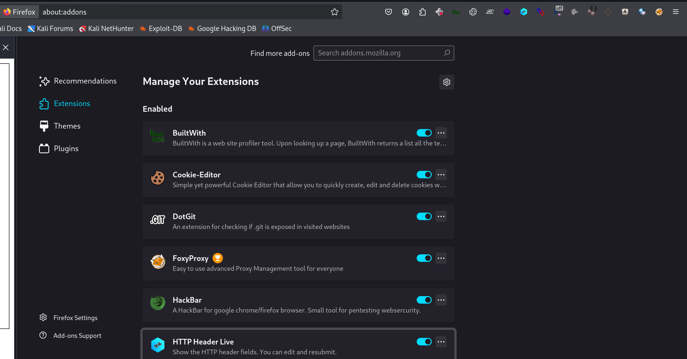
3) wappalyzer demo
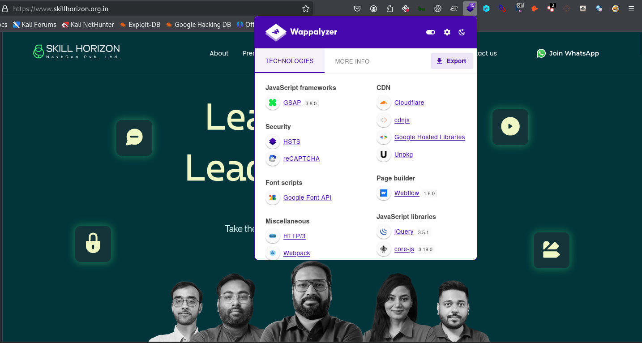
4)Burpsuite
(inside burpsuite – proxy setting)
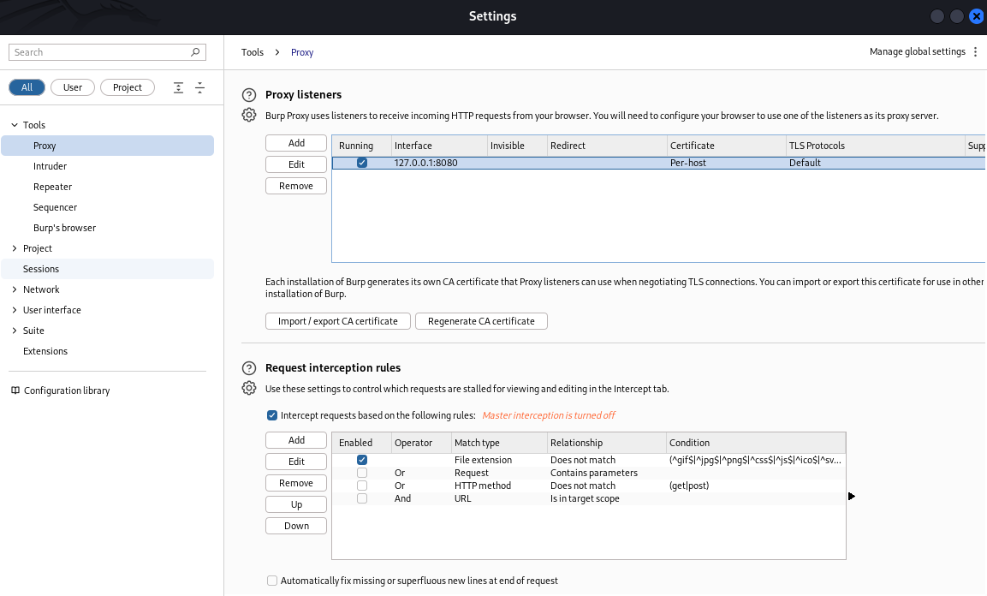
5)foxyproxy
(inside foxyproxy proxy settings) (Title,Hostname,Portname)
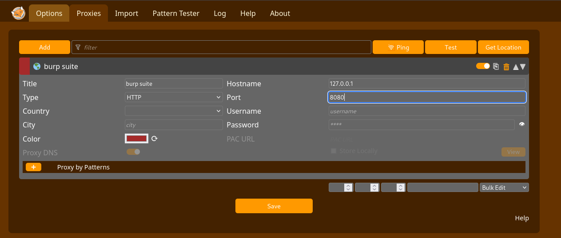

6)Install Burpsuite certificate in browser(Choose export certificate)
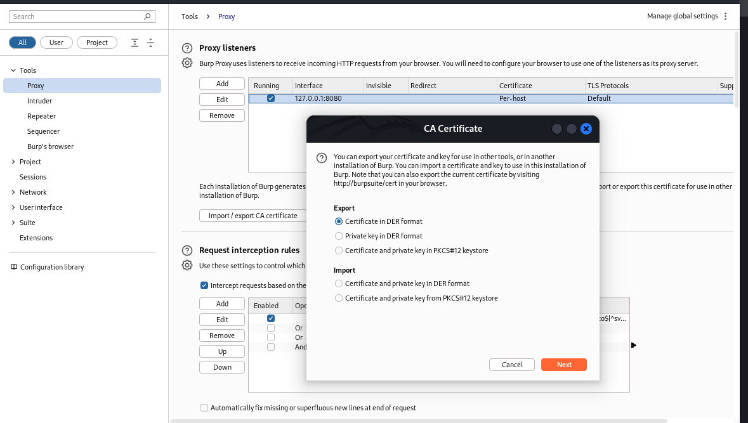
7) 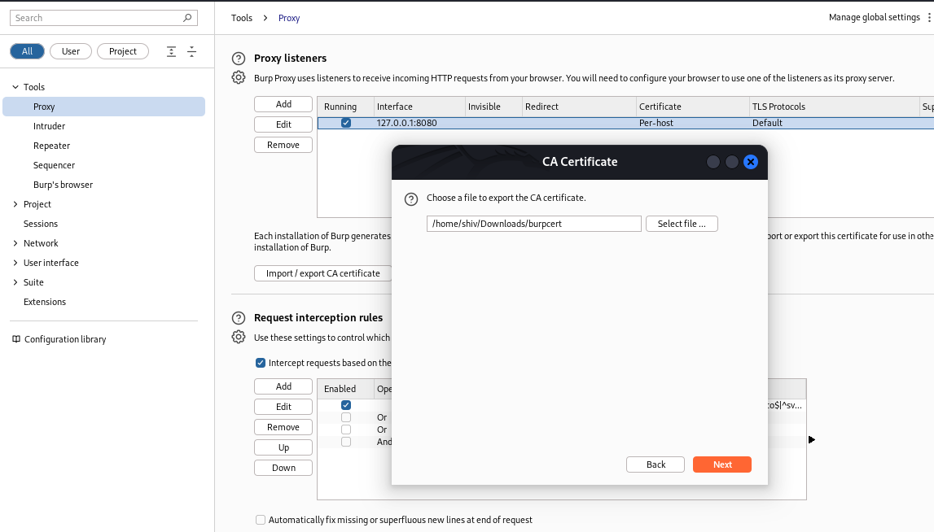
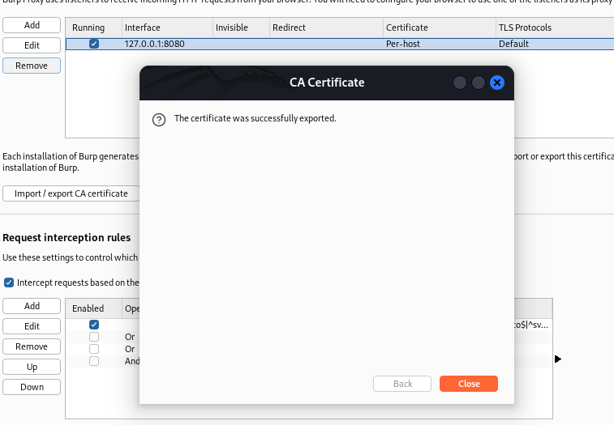
8) 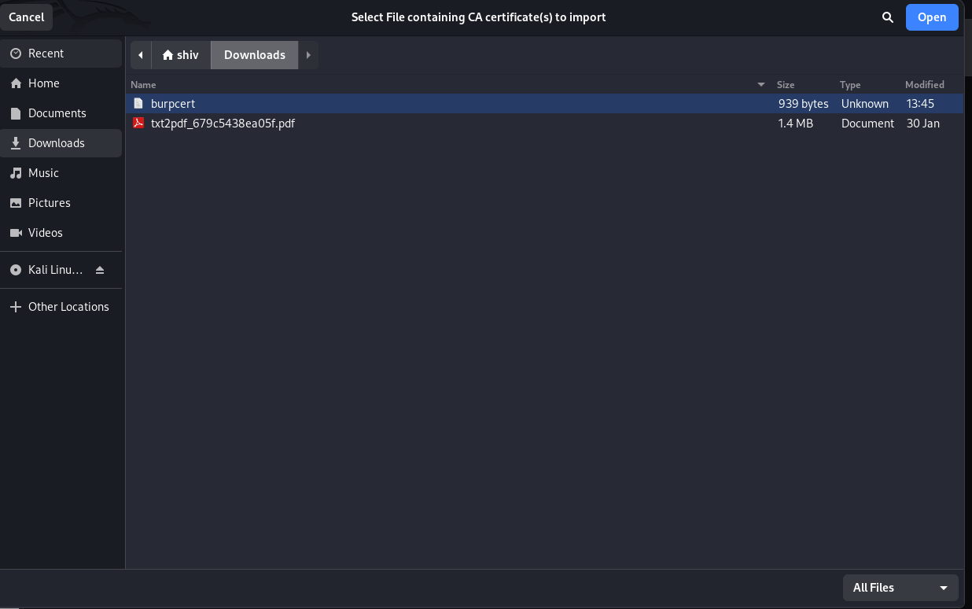
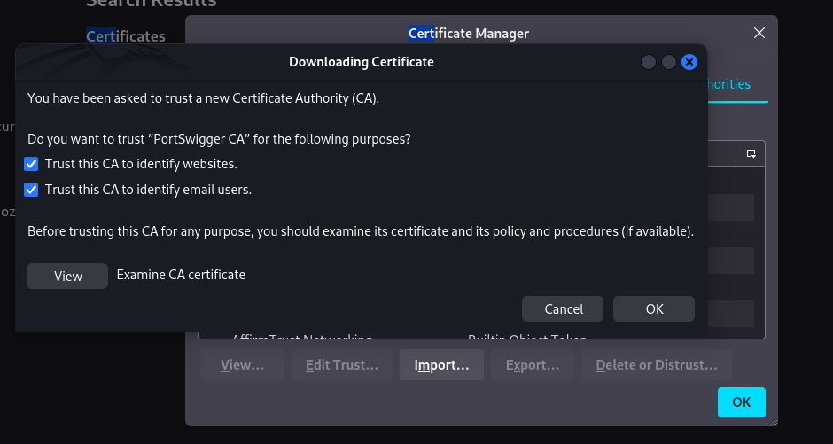
9) Sudo apt command to install go language in linux using terminal
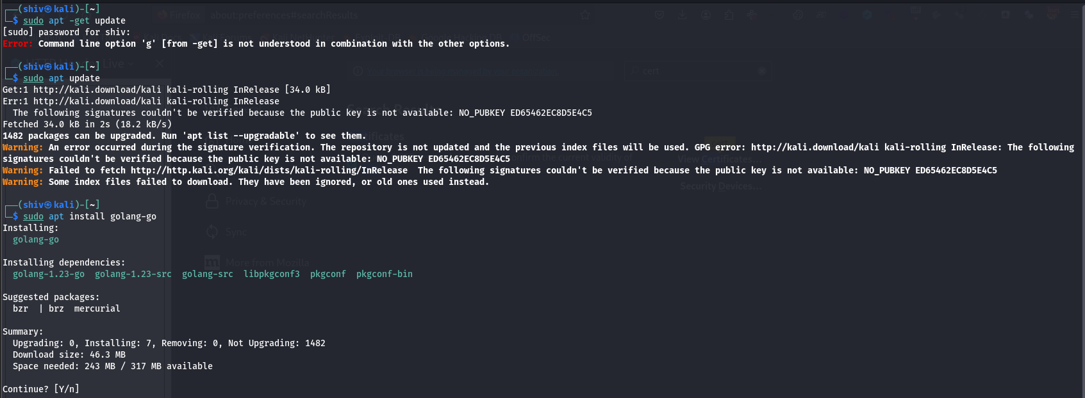
Validate Go version name!
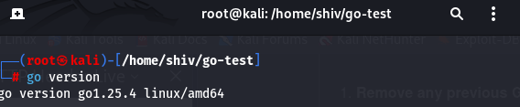
10) Traffic coming to burpsuit
